U509 - Lesson 2
Engaging Stakeholders
How organisations engage stakeholders
The role of the manager
The benefits of creating an engagement plan

Stakeholder Expectations
To develop the relationship and make it fully reciprocal, an organisation must make its own expectations clear - for example, through contracts - but it must also understand the expectations of its stakeholders.
Failure to clarify what the expectations are - and to act on them - can have serious consequences.
Organisations can underestimate what really matters to stakeholders - especially if they’ve come to rely on them. But stakeholder loyalty can’t be taken for granted; it must be nurtured through active ‘engagement.’
Stakeholder Engagement
Its goal is to improve the relationship so that both parties feel their needs are being met. This includes proactive communication. Seeking out stakeholder views through surveys, providing updates through newsletters, and hosting meetings and events are all means of engagement.
The payoff for all this effort is a stakeholder who feels valued and respected, and therefore more likely to support it on a long term basis. also likelier to ‘buy-in,’ or commit, to the organisation’s riskier projects.
Stakeholder Power
The researchers Andrew L. Friedman and Samantha Miles argue that the depth of engagement is determined by the stakeholder’s power.
Those who have low levels of power, engagement mainly takes the form of ‘informing’ them, and ‘explaining’ the company’s positions.
Partnerships
As power rises, the organisation begins to ‘consult’ them more extensively, perhaps ‘collaborating’ on individual projects.
Managing Stakeholder Engagement
The complex nature of engagement requires some forethought and planning, and this responsibility will generally rest with the managers in the organization.
This includes strategizing HOW stakeholders are engaged with, even if it is not directly by themselves. EG - The nature of conversations from a Call Center with Customers.
Engagement Hierarchies
Different levels of responsibility within the Stakeholder relationship triangle will engage with stakeholders in different ways. For example, a CEO for a College might host forums with MPs or Local Politicians and Business owners.
This level of engagement could be more detailed with plans, or advertising through showcase events.
Middle Managers will engage with a different variety of stakeholders, from external and internal. These might be more processed and specific in terms of the contract and service.
Roles like mine will likely engage with internal stakeholders with some very specific and narrow engagement with external stakeholders.
A similar hierarchy applies to engagement with internal stakeholders. Here the manager’s rank will determine the scope of the planning. Senior managers will make plans and policies that affect relations with all employees in the company, including the staff working directly for them. Managers further down the ranks will only do so for their own teams.

Krick and Forstater’s Framework
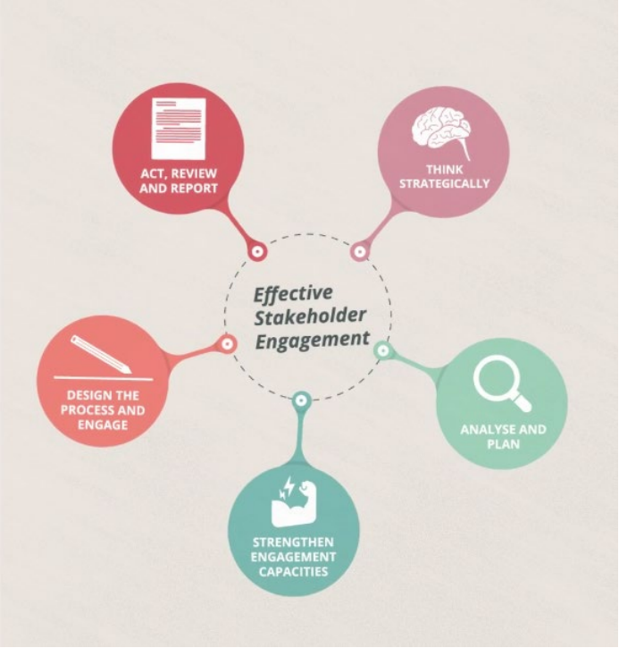
Engagement must be adapted to suit particular stakeholders. This means strategic planning is essential.
Researchers Thomas Krick, Maya Forstater and colleagues have developed a five stage framework for engagement that emphasises planning. The framework may be applied to both new and existing stakeholders, as these relationships can change over time, requiring new approaches.
Krick and Forstater’s Framework - Stage 1 - Strategic thinking
Any engagement approach should fit within the broader goals of the organisation. This will ensure that the relationship benefits both parties.
Start with identifying the organisation’s ‘strategic objectives’ - the critical targets for the entire company.
Understanding the company’s overall goals can help managers identify how the relationship might align with its broader strategy. This applies to managers at every level in the hierarchy, and both internal and external stakeholders.
Managers can then study how its stakeholders fit into this vision.
Krick and Forstater’s Framework - Stage 2 - Analyse and Plan
Stage 2 requires managers to ‘analyse’ individual stakeholder needs and expectations, and ‘plan’ their engagement based on this information - research to gauge stakeholder priorities.
Primary research,
also known as ‘field’ research, requires the gathering of new data by the manager. This can be done by a variety of means - surveys and focus groups are two ‘structured’ methods.
Surveys and Focus Groups
Surveys - identify trends or opinions ... data may be kept anonymous ... confidentiality is important.
Focus groups - offer their views about a product, service, or proposed change. The group can sometimes give a fuller idea of the feelings around an issue than a survey, which is limited by its static format.
Networking
This can produce information about stakeholders within a particular industry.
Secondary Research
‘Desk’ research involves collecting information that has been gathered and interpreted by others. Secondary research can be carried out without any interaction with the stakeholder.
This may be research done by other organisations, including businesses, non-profit groups and government agencies like the Office for National Statistics, or education charity organisations like Jisc.
Setting Engagement Objectives
Build profiles of stakeholders, which will then be used to set objectives for the engagement.
The objective is the core element of the engagement plan; the rest of the plan will cover the actual timing and method of engagement - who will contact the stakeholder, how often and by what means.
Krick and Forstater’s Framework - Stage 3 - Strengthen Engagement Capabilities
Using the data gathered, produce a detailed proposal / plan for how to engage with specific stakeholders.
The organisation may need to ‘strengthen’ its ‘capacities’ to engage stakeholders according to the new plan. This is where the organization may not be fully capable of making the most of stakeholder engagement and will therefore need to adapt.
Krick and Forstater’s Framework - Stage 4 - Design the process & Engage
Research and planning is turned into action.
The manager’s focus will now shift to the methods of engagement which best meet the objectives set out in the plan. This will require a good understanding of the communication tools at their disposal - ‘convey’ information or to ‘exchange’ it.
One and Two Way Communication
ONE-WAY - Presentations, webinars, newsletters and reports are key ways to convey information to stakeholders.
two way communication - one to one or group meetings, social events, phone calls and emails.
Stakeholder Status
The higher their level of power, the more personal and interactive the communication becomes.
This reflects the different ‘levels’ of engagement, as set out by Friedman and Miles, which change as stakeholder power increases.
So for example, a charity will keep its contributors updated on its activities via an email newsletter. But its major donors will be invited to private lunches, and opportunities to meet the beneficiaries of its work.
Krick and Forstater’s Framework - Stage 5 - Act, Review & Report
Act - refers to action the organisation takes as a result of engaging the stakeholder. For example, using their feedback to change the timelines on a project.
Review - represents an evaluation of the whole engagement process, noting which methods worked well, where there is room for improvement and what form it should take.
Report - refers to ways the company may communicate the action to the stakeholder. This could literally be a report, but equally it could consist of meetings or email updates, depending on the company, project and stakeholder status.
Any lessons learned can then be used to update the engagement plan - Do this regularly BECAUSE stakeholder positions can change. This is a key moment in maintaining healthy relationships.

Influencing Stakeholders
It’s possible to maintain stakeholder relationships without a formal engagement plan - this is often the case with secondary and low power stakeholders. However, as this position changes and their involvement increases, the Krick and Forstater model we saw earlier can be helpful.
According to the CMI, ‘influencing’ is ‘the ability to form, shift or alter the opinions and behaviour of others’ - to bring them round to a way of thinking.
Engagement Methods
The engagement methods used for these purposes can also vary widely, from one way communication tools, like speeches or newsletters, to more interactive ones, like meetings.
Presentations offer a useful way of engaging stakeholders and presenting important information. So, as a manager, it is important for you to be able to present effectively.

